

**Course Name**: EMBEDDED SYSTEMS I / III

**Course Number and Section**: **14:332:493:03**

**Year: Spring 2021**

**Final Lab Report**

**Lab Instructor**: Philip Southard

**Student Name and RUID**: Matthew Hanna; RUID:178001207

Fady Shehata; RUID: 189009075

**Date Submitted**: 5/5/2021

**GitHub Link:** <https://github.com/matthanna99/project>

**Purpose/Objective:**

The Objective of this project is to optimize the home or office environment which in itself optimizes the quality of life/work. What we mean by optimizing the workspace is that we need to control the temperature, humidity and the amount of light in a given space. This project tends to inform the user of whether the area they are in falls in the recommended range in terms of temperature, humidity and amount of light.

**Theory of Operation:**

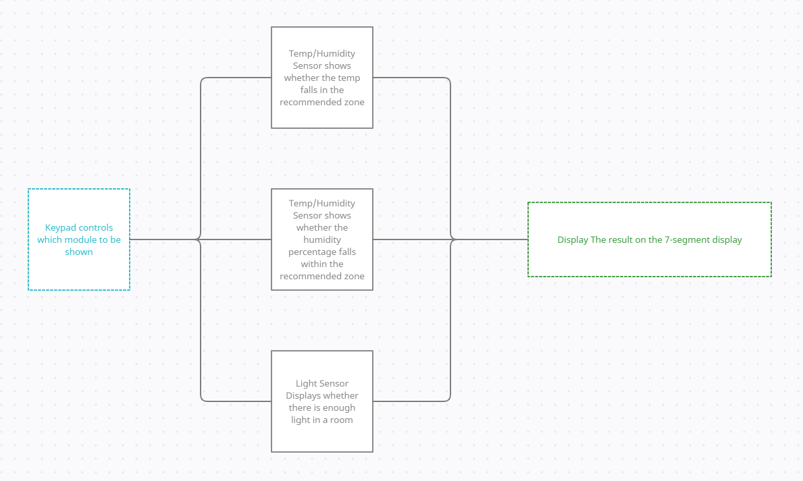

**Vivado Schematics:**

Keypad Decoder Elaboration Schematic: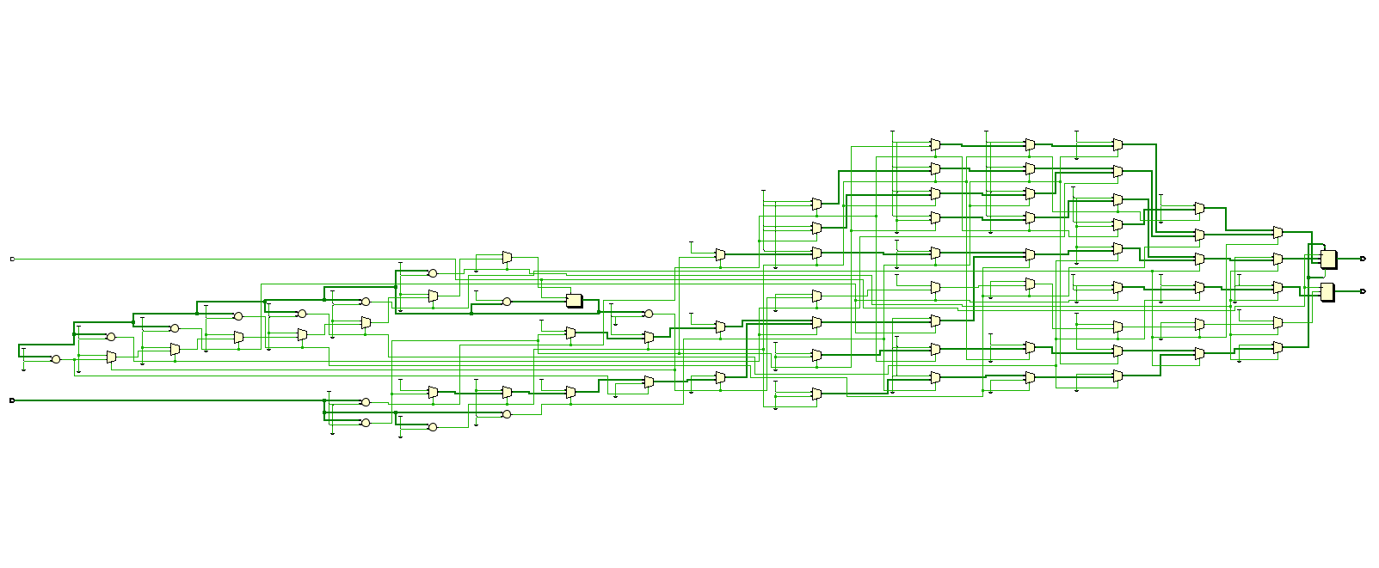

Keypad Decoder Synthesis Schematic: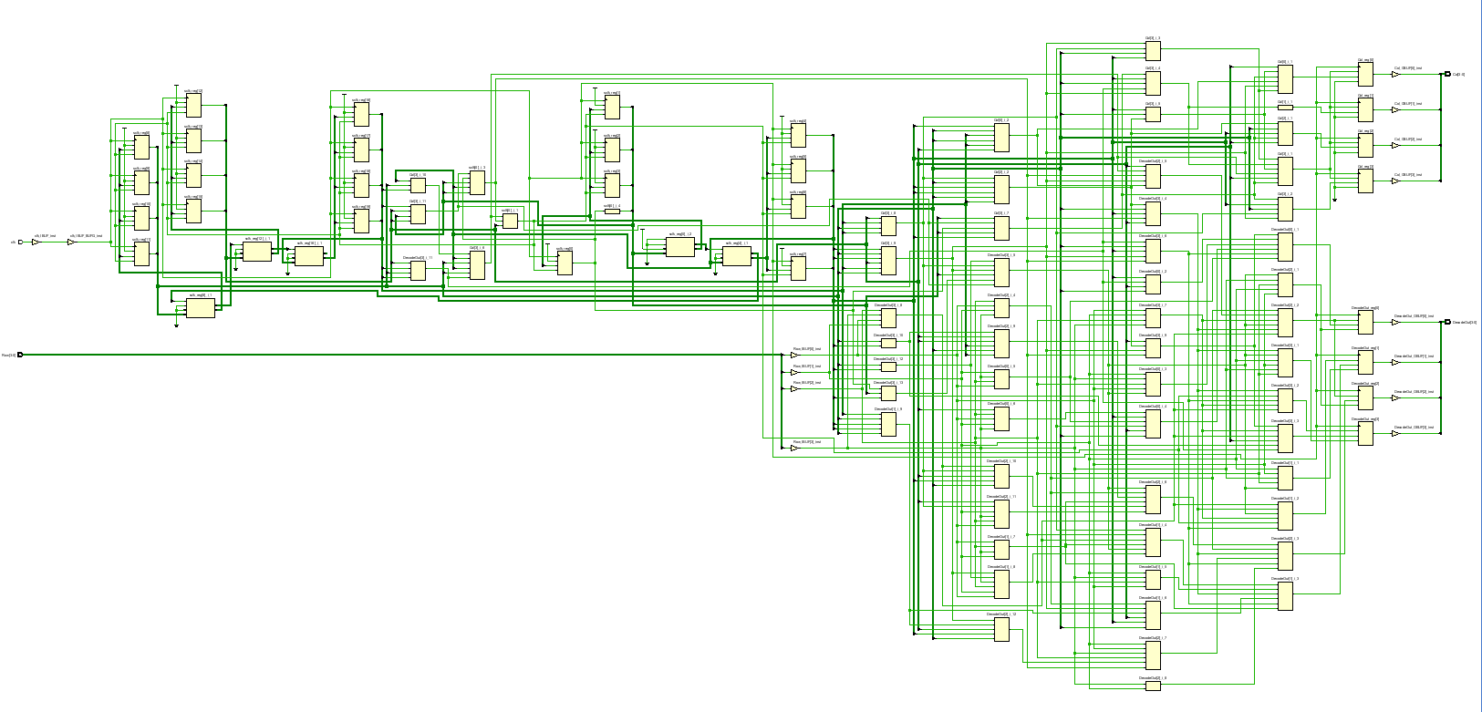

Display Controller Elaboration Schematic:

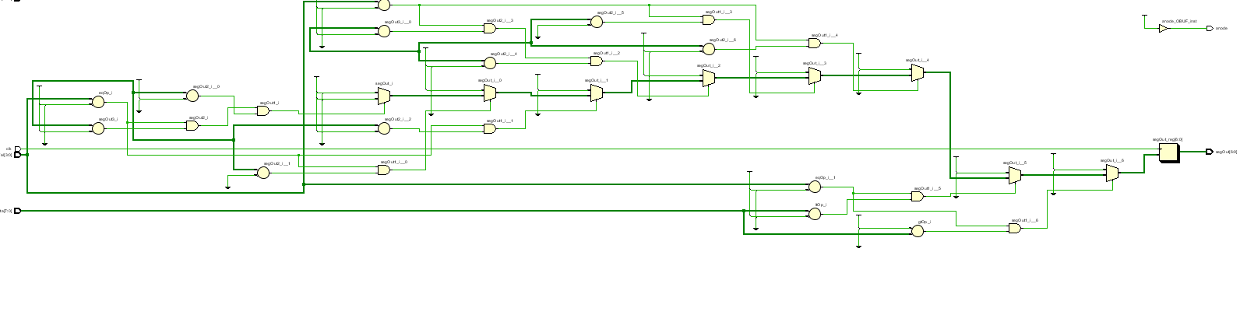

Display Controller Synthesis Schematic: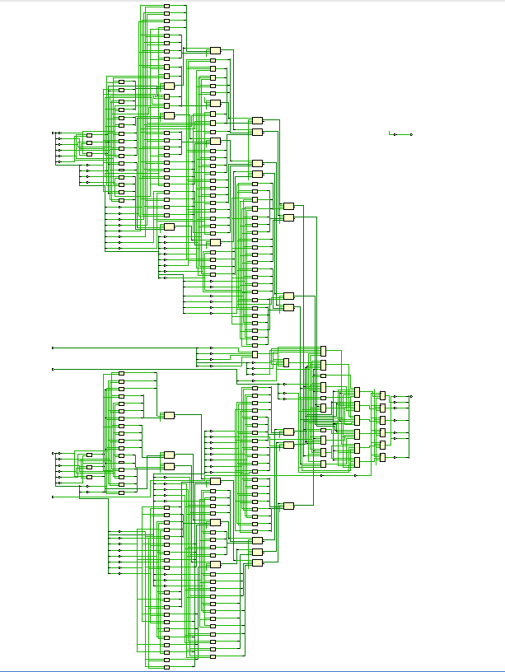

Ambient Light Sensor Elaboration Schematic: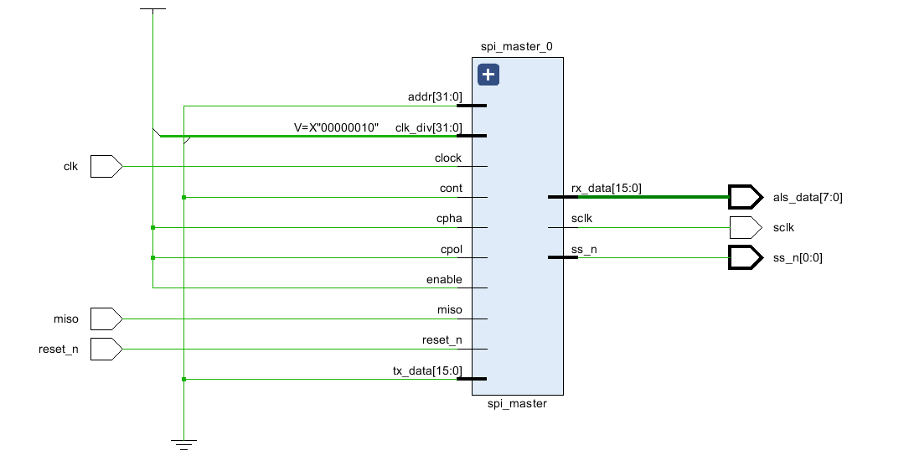

Ambient Light Sensor Synthesis Schematic:

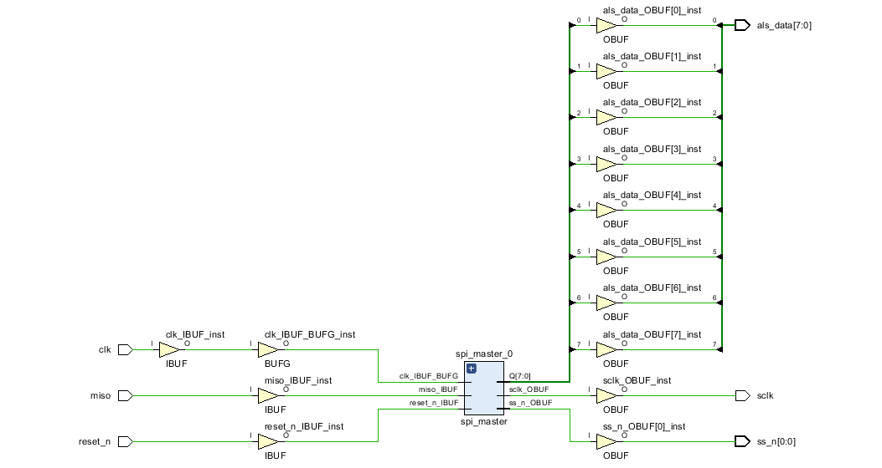

Temperature and Humidity Sensor Elaboration Schematic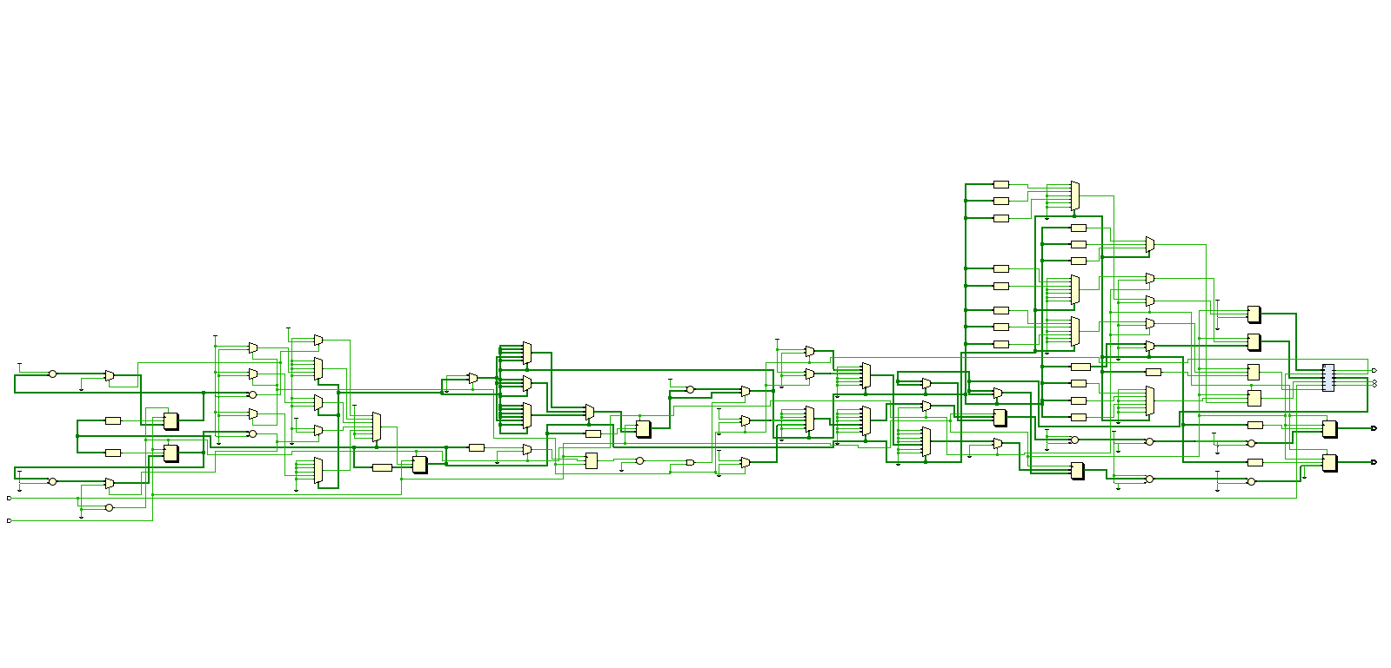

Temperature and Humidity Sensor Synthesis Schematic:

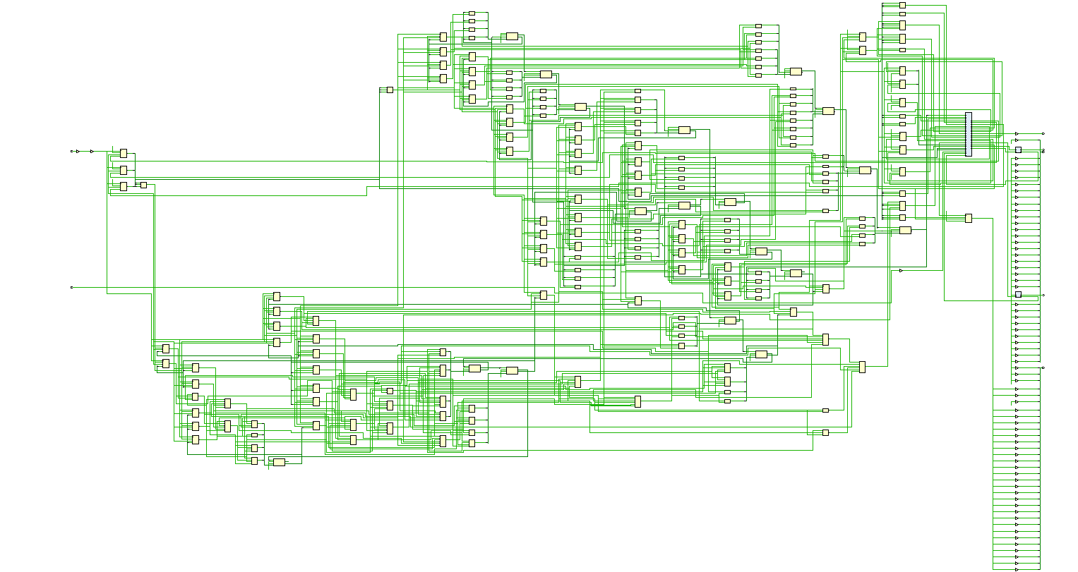

Top Level Elaboration Schematic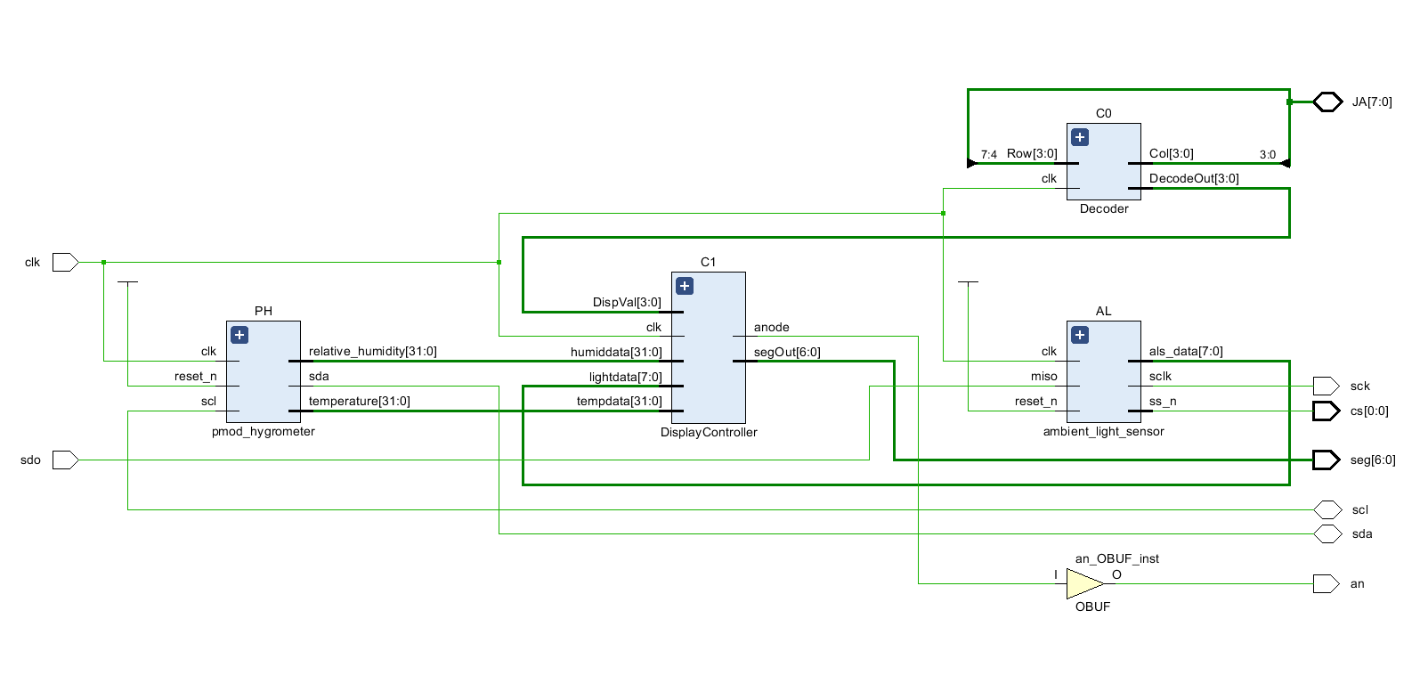

Synthesis Schematic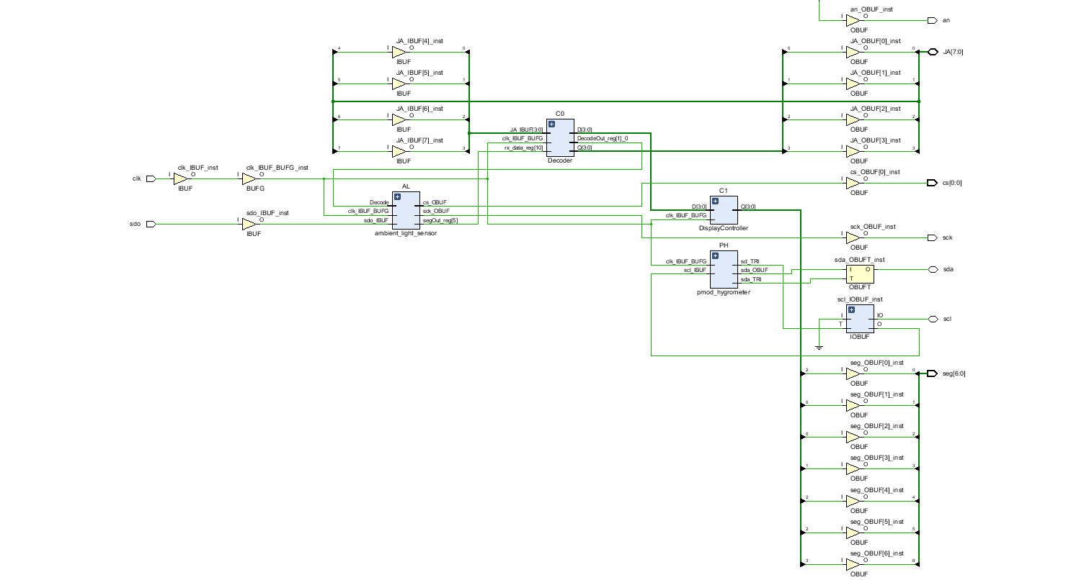

Utilization Report and Power Graphs

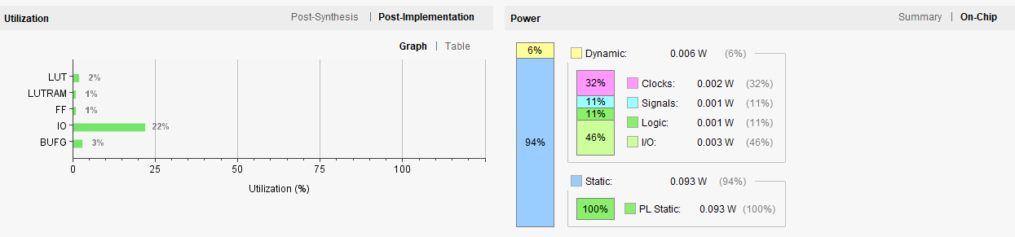

**Constraints File:**

The Constraints file was modified to accommodate the four pmods we used. The Keypad was connected to the 8 ports within JA. Display was connected to both JC & JD utilizing their top rows only. For JE, we connected the top row to the Hygro pmod and the bottom to the Ambient light pmod.

**Conclusion:**

This Project was very exciting to work on as it provided us with a hands-on experience of the thought process, the work procedure and the flow of work. We were successful in writing a working code for the project and testing it on the board. The tests concluded the success of the keypad pmod, the 7-segment display and the light sensor. The keypad pmod was able to switch between different commands as it was intended to. The display successfully displayed any number or letter within the specifications. Finally the light sensor was able to accurately detect the light inside a room.

**Follow Up:**

As stated above most of the Project parts were working properly. On the other hand, one part which is the hygro (temperature and humidity ) wasn’t working properly. With further testing we detected that there is a high chance that the sensor is malfunctioning because we weren't able to detect any current at the VCC. Time was a huge variable on this and it didn’t allow us to purchase a new part so we were only able to demo the other parts of the project.